**Lab Practice 4 – Database Systems (Creating Tables)**

**Roll No: (2k20/ITE/73) Name: Mubashir Ali**

**Practice Question 1**

Create the **DEPT** table based on the following table instance chart.

**See output below**

DEPT

|  |  |
| --- | --- |
| ID | Name |
| Length (7) Number | Length(25) varchar |

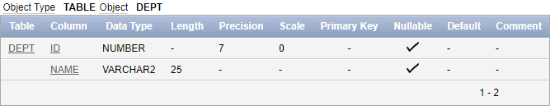

Answer:

Create table DEPT(ID number(7),Name Varchar(25));

Describe DEPT;

**Practice Question 2**

Create the **EMP** table based on the following table instance chart.

**See output below**

|  |  |  |  |
| --- | --- | --- | --- |
| ID | Last_Name | First_Name | DEPT_ID |
| Length (7) Number | Length(25) varchar | Length(25) varchar | Length(7) number |

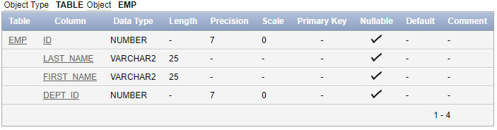

**Answer:**

Create table EMP(ID number(7),Last_Name Varchar(25),First_Name Varchar(25),Dept_ID Varchar(7));

Describe EMP;

**Practice Question 3**

Insert data into DEPT Table. Data is shown in following output

**See output below**

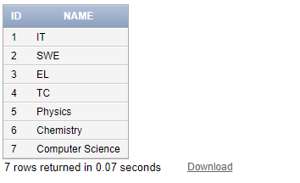

**Answer:**

**1. Insert into DEPT(ID,NAME)**

**VALUES(1,'IT');**

**2. Insert into DEPT(ID,NAME)**

**VALUES(2,'SWE');**

**3. Insert into DEPT(ID,NAME)**

**VALUES(3,'EL');**

**4. Insert into DEPT(ID,NAME)**

**VALUES(4,'TC');**

**5. Insert into DEPT(ID,NAME)**

**VALUES(5,'Physics');**

**6.Insert into DEPT(ID,NAME)**

**VALUES(6,'Chemistry');**

**7.Insert into DEPT(ID,NAME)**

**VALUES(7,'Computer Science');**

**Select \***

**From DEPT;**

**Practice Question 4**

Insert data into EMP Table. Data is shown in following output

**See output below**

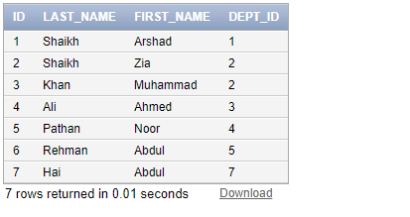

**Answer:**

**1. Insert into EMP(ID,LAST_NAME,FIRST_NAME,DEPT_ID)**

**VALUES(1,'Shaikh','Arshad',1);**

**2.Insert into EMP(ID,LAST_NAME,FIRST_NAME,DEPT_ID)**

**VALUES(1,'Shaikh','Zia',2);**

**3. Insert into EMP(ID,LAST_NAME,FIRST_NAME,DEPT_ID)**

**VALUES(1,'Khan','Muhammad',3);**

**4. Insert into EMP(ID,LAST_NAME,FIRST_NAME,DEPT_ID)**

**VALUES(1,'Ali','Ahmed',4);**

**5. Insert into EMP(ID,LAST_NAME,FIRST_NAME,DEPT_ID)**

**VALUES(1,'Pathan','Noor',1);**

**6.Insert into EMP(ID,LAST_NAME,FIRST_NAME,DEPT_ID)**

**VALUES(1,'Rehman','Abdul',1);**

**7.Insert into EMP(ID,LAST_NAME,FIRST_NAME,DEPT_ID)**

**VALUES(1,'Hai','Abdul',1);**

**Select \***

**From EMP;**

**Practice Question 5**

Create the **EMP2** table based on the following table instance chart.

**See output below**

|  |  |  |  |
| --- | --- | --- | --- |
| ID | Last_Name | First_Name | Hire_date |
| Length (7) Number | Length(25) varchar | Length(25) varchar | Date |

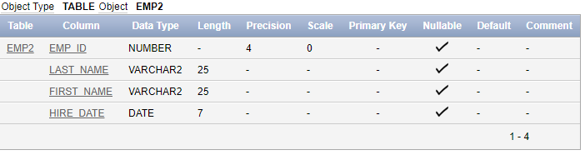

Answer:

Create table EMP2(ID number(7),Last_Name Varchar(25),First_Name Varchar(25),Hire_Date Date);

Describe EMP2;

**Practice Question 6**

Insert data into **EMP2** Table. Data is shown in following output

**See output below (data can be in any sequence)**

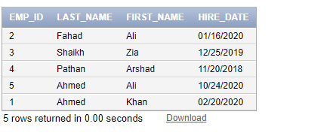

**Answer:**

**1. Insert into EMP2(ID,LAST_NAME,FIRST_NAME,HIRE_DATE)**

**VALUES(2,'Fahad','Ali','01/16/2020');**

**2. Insert into EMP2(ID,LAST_NAME,FIRST_NAME,HIRE_DATE)**

**VALUES(2,'Shaikh','Zia','12/25/2019');**

**3. Insert into EMP2(ID,LAST_NAME,FIRST_NAME,HIRE_DATE)**

**VALUES(3,'Pathan','Arshad','11/20/2018');**

**4. Insert into EMP2(ID,LAST_NAME,FIRST_NAME,HIRE_DATE)**

**VALUES(4,'Ahmed','Ali','10/24/2020');**

**5. Insert into EMP2(ID,LAST_NAME,FIRST_NAME,HIRE_DATE)**

**VALUES(5,'Ahmed','Khan','02/20/2020');**

**Select \***

**From EMP2;**

**Practice Question 7**

Try to insert a record into EMP2 Table using **SYSDATE** keyword of Oracle.

i.e insert into emp2 values(6, 'You Last Name', 'Your First name', SYSDATE)

**Answer:**

**Insert into EMP2(ID,LAST_NAME,FIRST_NAME,HIRE_DATE)**

**VALUES(6,'Ali','Mubashir',SYSDATE);**

**Practice Question 8**

Creating an **EMP3** Table from the rows returned from **EMP2** and copying data returned from query.

Try following query

**create table emp3**

**AS**

**select emp_id, last_name, first_name, hire_date from emp2**

**Correct Query:**

**Answer:**

**create table EMP3**

**AS**

**select ID as Emp_id,LAST_NAME as last_name,FIRST_NAME as first_name,HIRE_DATE as hire_date**

**from EMP2;**

**select \***

**from EMP3;**

**Practice Question 9**

Create an **EMP4** table from the following row returned from employees table

|  |  |  |  |  |  |
| --- | --- | --- | --- | --- | --- |
| **Employee_id** | **First_name** | **Last_name** | **Job_id** | **Salary** | **Hire_date** |
|  |  |  |  |  |  |

**Answer:**

**create table EMP4**

**AS**

**select Employee_id,First_name,Last_name,Job_id,Salary,Hire_date**

**from Employees;**

**select \***

**from Employees;**

**Practice Question 10**

Create a **Students’** table with timestamp datatype of admission date attribute

|  |  |  |  |  |  |
| --- | --- | --- | --- | --- | --- |
| **Roll_no** | **First_name** | **Last_name** | **Address** | **Phone** | **Admission_date** |
| Length(7)  Number | Length(20)  Varchar | Length(20)  Varchar | Length(3)  Varchar | Length(8)  Number | Timestamp |

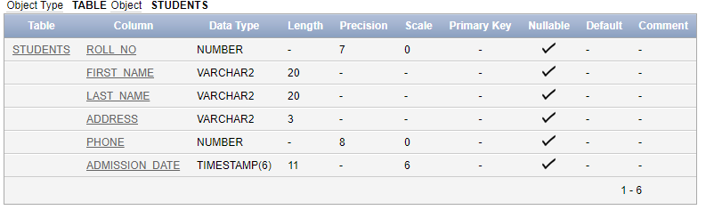

**Answer:**

Create table Students(Roll_no number(7),First_name Varchar(20),Last_name Varchar(20),Address Varchar(3),Phone number(8),Admission_date Timestamp);

Describe Students;

**Practice Question 11**

Insert data into **Students** Table. See data below (User SYSDATE to insert current date and time)

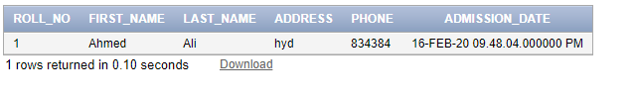

**Insert into Students(Roll_no,FIRST_NAME,LAST_NAME,Address,Phone,Admission_date)**

**VALUES(1,'Ahmed','Ali','hyd',834384,SYSDATE);**

Select *

From Students;